# Mathematical Logic

Homework 1

## Question 2

f(A, B, C) = (A→(B⋀¬C))↔((¬B⋁A)→(A→¬C))

|  |  |  |  |  |  |  |  |  |  |  |
| --- | --- | --- | --- | --- | --- | --- | --- | --- | --- | --- |
| **A** | **B** | **C** | **¬C** | **B⋀¬C** | **A→(B⋀¬C)** | **¬B** | **¬B⋁A** | **A→¬C** | **(¬B⋁A)→(A→¬C)** | **f(A, B, C)** |
| T | T | T | F | F | F | F | T | F | F | T |
| T | T | F | T | T | T | F | T | T | T | T |
| T | F | T | F | F | F | T | T | F | F | T |
| T | F | F | T | F | F | T | T | T | T | F |
| F | T | T | F | F | T | F | F | T | T | T |
| F | T | F | T | T | T | F | F | T | T | T |
| F | F | T | F | F | T | T | T | T | T | T |
| F | F | F | T | F | T | T | T | T | T | T |

### Question 2a

g(A)=T, g(B)=F, g(C)=T

f(T, F, T) = T

### Question 2b

g(A)=F, g(B)=F, g(C)=F

f(F, F, F) = T

## Question 4

### Question 4a

Y→(R⋀¬S)

True

### Question 4b

(S⋁R)→¬Y

False

### Question 4c

((¬R→¬Y)⋀¬S)→(Y⋀R)

True

## Question 6

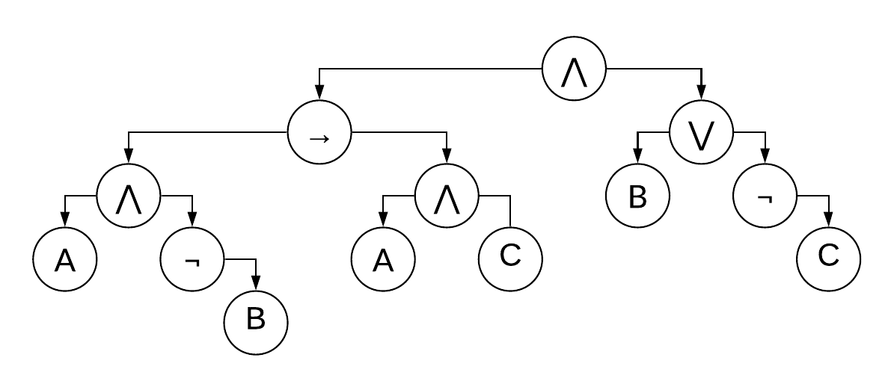

[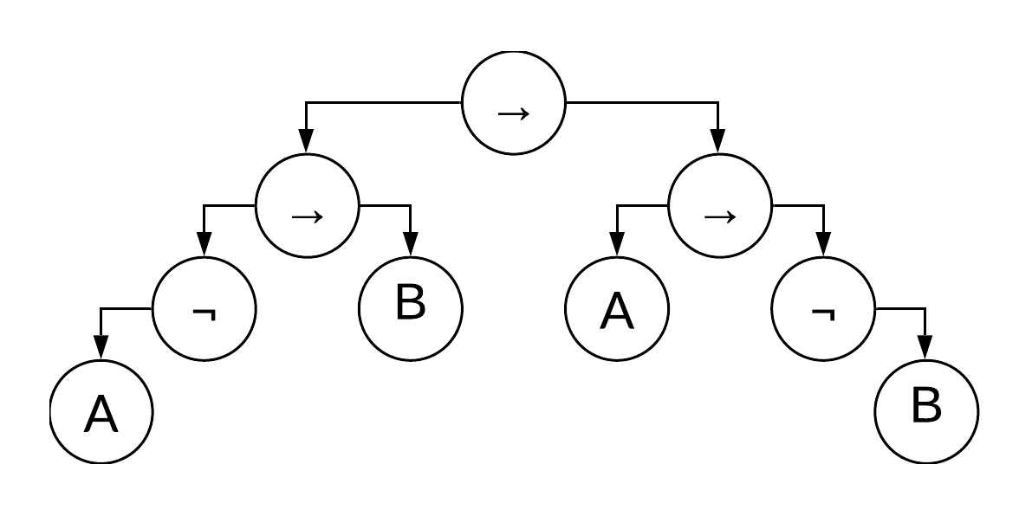](https://www.lucidchart.com/documents/edit/24d77149-9a4e-4d16-8048-440e9d95bc1e/0?callback=close&name=docs&callback_type=back&v=177&s=595.2755905511812)

[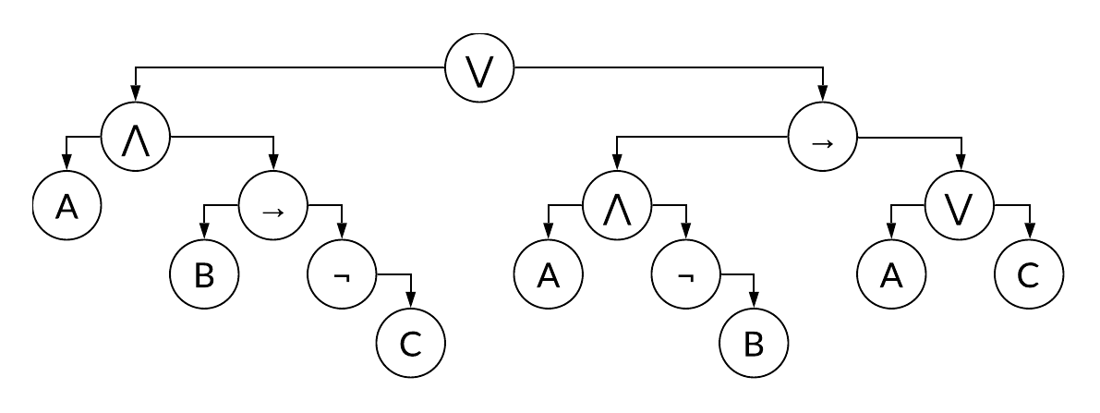](https://www.lucidchart.com/documents/edit/39296ea8-cfe3-47be-a7bb-559abeab418e/0?callback=close&name=docs&callback_type=back&v=230&s=595.2755905511812)

## Question 8

### Question 8a

Let N be a proposition.

Let L be a literal, P and Q be propositions, and @ be a binary logical operator.

N can be made up of the following blocks:

|  |  |
| --- | --- |
| **N** | **For any beginning of N, the number of left parentheses is larger than or equal to the number of right parentheses.** |
| L | True. Before the literal there are no left or right parentheses, and after there are none either. |
| ¬P | True, only if it is true for P, since there are no left or right parentheses outside of P. |
| P @ Q | True, only if it is true for both P and Q, since there are no parentheses outside of P and Q |
| (P) | True, only if it is true for P, since the only left parentheses outside of P is the first character in N, and the only right one outside of P is the last character in N. |

So since N is always true only if its sub propositions are true, and all sub propositions are made up of literals or other sub propositions, and it is always true for literals, therefore it is true for any proposition.

### Question 8b

Let N be a proposition. Let N( be the number of left parentheses and N) be the number of right parentheses in N.

Let L be a literal, P and Q be propositions, and @ be a binary logical operator.

N can be made up of the following blocks:

|  |  |  |
| --- | --- | --- |
| **N** | **N(** | **N)** |
| L | 0 | 0 |
| ¬P | P( | P) |
| P @ Q | P( + Q( | P) + Q) |
| (P) | P( + 1 | P) + 1 |

In all of these cases we see that N( = N).